***A Mini Project Synopsis on***

## Resume Craft: Resume Builder

Submitted in partial fulfillment of the requirements for the degree

### Second Year Engineering – Computer Science and Engineering (Data Science) Submitted By

|  |  |
| --- | --- |
| **Vaishnavi Bhojak** | **23107022** |
| **Nishigandha Sawant** | **23107047** |
| **Nidhi Shettigar** | **23107041** |
| **Aditya Bhoir** | **23107006** |

**Under the guidance of**

### Ms. Ujwala Pagare



**DEPARTMENT OF COMPUTER SCIENCE AND ENGINEERING (DATA SCIENCE)**

A.P. SHAH INSTITUTE OF TECHNOLOGY  
G.B. Road, Kasarvadavali, Thane (W), Mumbai 400615  
 UNIVERSITY OF MUMBAI

**Academic year: 2024-25**

# CERTIFICATE

This to certify that the Mini Project report on Resume Craft- Resume Builder has been submitted by **Vaishnavi Bhojak** (**23107022**), **Nishigandha Sawant** (**23107047**), **Nidhi Shettigar** (**23107041**) and **Aditya Bhoir** (**23107006**) who are bonafide students of A. P. Shah Institute of Technology, Thane as a partial fulfillment of the requirement for the degree in **Computer Science Engineering (Data Science)**, during the academic year **2024-2025** in the satisfactory manner as per the curriculum laid down by University of Mumbai.

**Ms. Ujwala Pagare**

**Guide**

**Ms. Anagha Aher Dr. Uttam D. Kolekar**

**HOD, CSE (Data Science) Principal**

**External Examiner: Internal Examiner:**

**1. 1.**

**Place:** A. P. Shah Institute of Technology, Thane  
**Date:**

# ACKNOWLEDGEMENT

This project would not have come to fruition without the invaluable help of our guide **Mr. Ujwala Pagare**. Expressing gratitude towards our HoD, **Ms. Anagha Aher**, and the Department of Computer Science Engineering (Data Science) for providing us with the opportunity as well as the support required to pursue this project. We would also like to thank our project coordinator **Ms. Rajashri Chaudhari and Mr. Vaibhav Yavalkar** who gave us his/her valuable suggestions and ideas when we were in need of them. We would also like to thank our peers for their helpful suggestions.

# TABLE OF CONTENTS

1. Introduction 1
   1. Purpose 1
   2. Problem Statement 1
   3. Objectives 2
   4. Scope 2
2. Proposed System 3
   1. Features and Functionality 3
3. Project Outcomes 6
4. Software Requirements 7
5. Project Design 8
6. Project Scheduling. 10
7. Results 11
8. Conclusion 12

References

## Chapter 1

### Introduction

With the growing dependence on digital platforms for career advancement and job applications, the need for effective resume-building tools has become increasingly evident. This chapter explores the motivation behind creating the resume-building app, addressing common challenges like inefficient resume creation, disorganization, and the difficulty of tailoring resumes to specific jobs. Many job seekers face issues with inconsistent formatting, missing details, or irrelevant content. The app seeks to resolve these problems by offering a user-friendly interface, customizable templates, and content suggestions, enabling users to quickly craft polished, professional resumes that catch the attention of employers.

### Purpose

The primary goal of this resume-building app is to provide users with a convenient and organized platform for creating, customizing, and managing their resumes. Whether for personal career development or professional job applications, the app is designed to streamline the resume creation process. Additionally, the app aims to boost user efficiency by offering quick access to professional templates, guidance on content, and tools for easy adjustments. With a focus on security and ease of use, the app becomes an essential tool for both preparing resumes and updating them over time.

### Problem Statement

In an increasingly digital world, individuals often face challenges when creating and organizing professional resumes. Traditional resume-building methods can result in inconsistent formatting, difficulties in customization, and lack of accessibility across devices. This app aims to solve these problems by providing a seamless experience for users to create, manage, and customize resumes with ease. Additionally, users can tailor their resumes for specific job applications, prioritize key sections, and set reminders for important tasks such as updating information or submitting applications, ensuring proper organization and career management.Objectives

**1.3 Objectives**

* Develop a user-friendly login and signup system using JavaFX
* Enable efficient management of user skills, qualifications, and personal information.
* Include the user's profile picture in the resume for a professional presentation.
* Use JDBC to generate and download resumes in PDF format.

### 1.4 Scope

* + - . The development of an intuitive and functional user interface. A well-designed UI is essential for a resume-building app, as it directly impacts user experience and usability. For the resume builder, the interface should be clean, easy to navigate, and reduce the learning curve for new user.
    - Integration of sections and customization options to organize resumes. Effective organization is crucial for any resume-building app. Sections and customization options allow users to structure their resumes, highlight key details, and tailor them for specific job applications efficiently.
    - Basic encryption for user data security. In an age where data protection is critical, safeguarding user information in a resume-building app is essential.

## Chapter 2

### Proposed System

Whether for personal career development, job applications, or professional networking, the app provides features such as section organization and customization options, making it easy for users to create and tailor their resumes.

### Features and Functionalities:

* **Easy Login/Signup:** Quick account creation and login process
* **Edit Personal Information**: Easily update personal and educational details.
* **Add Skills:**  Include up to four skills to showcase qualifications.
* **Profile Image Upload:**  Add a personal image to the resume.
* **Edit Profile Information**: Update profile details and change the photo anytime.
* **Downloadable PDF Resumes:**  Save resumes in PDF format for easy sharing

## Chapter 3

### Project Outcome

### The resume builder project successfully delivers a streamlined platform for users to create professional, customizable resumes with ease. It enhances user experience by providing an intuitive interface, secure data management, and the ability to upload profile photos. Users can generate well-formatted resumes and download them as PDF files, ensuring accessibility and efficiency in their job search. Additionally, the platform’s flexible design allows for continuous updates and future feature enhancements

1. **Functional Resume Builder:**

* A fully functional app where users can create, edit, and manage resumes seamlessly.
* Users can structure their resumes with sections for education, experience, skills, and more.

### User-Friendly Interface:

* An intuitive and easy-to-navigate interface that simplifies the resume-building process
* Features like guided prompts, customizable templates, and drag-and-drop functionality enhance usability

### User Authentication:

* A secure login and signup system that allows users to create account and access their resumes safely.

### Profile photo Integration:

* Users can upload and include a profile photo in their resumes for a personalized touch.
* Options to edit or replace the profile photo anytime

### Downloadable PDF Resumes:

* Users can generate well-formatted resumes and download them in PDF format for easy sharing and submission.

## Chapter 4

### Software Requirements

### The resume builder requires Java, utilizing JavaFX for an intuitive and responsive user interface, ensuring a seamless user experience. Additionally, MySQL is used for secure data storage, managing user information such as personal details, skills, and resumes, allowing for efficient access and updates.

**Front-end:**

* **Java NetBeans:** Apache NetBeans is a free, open-source integrated development environment (IDE) for Java and other programming languages. It provides comprehensive tools for developing desktop, web, and mobile applications with built-in support for Java, PHP, JavaScript, and more. With features like code editing, debugging, and project management, it simplifies software development.

### Back-end:

* **MySql Workbench:** MySQL is an open-source relational database management system (RDBMS) that uses structured query language (SQL) for managing and manipulating data. It is widely used for web applications and data storage due to its scalability, performance, and ease of use. MySQL supports largescale data operations and is commonly integrated with technologies like PHP, Python, and Java.

## Chapter 5

### Project Design

### The project features a clean and simple design that significantly enhances user experience. By prioritizing usability, it allows users to navigate effortlessly through the resume creation process. Each step is streamlined, with clearly defined sections dedicated to personal information, skills, and work experience, ensuring that users can focus on showcasing their qualifications effectively.

### Key Features:

### Intuitive Navigation: The interface is designed to guide users smoothly from one section to another. With a logical flow and accessible menus, users can easily jump to the area they want to edit or complete, making the process efficient and stress-free.

### Personal Information Section: This area is clearly laid out, allowing users to input essential details such as name, contact information, and professional summary. The design ensures that users can see how their information will appear on the final resume, providing real-time feedback and fostering a sense of accomplishment.

### Skills Showcase: The skills section offers a structured format for users to list their competencies. With the ability to categorize skills and highlight key areas of expertise, users can present their qualifications in a compelling manner. The design encourages users to think critically about their skills, promoting better self-assessment.

### Experience Overview: Users can effortlessly detail their professional history in a dedicated section that promotes clarity and impact. The design supports chronological, functional, or hybrid formats, enabling users to choose the best way to present their experiences. Predefined templates and tips help users articulate their achievements effectively, making it easier to stand out to potential employers.

### 

### Application Block Diagram

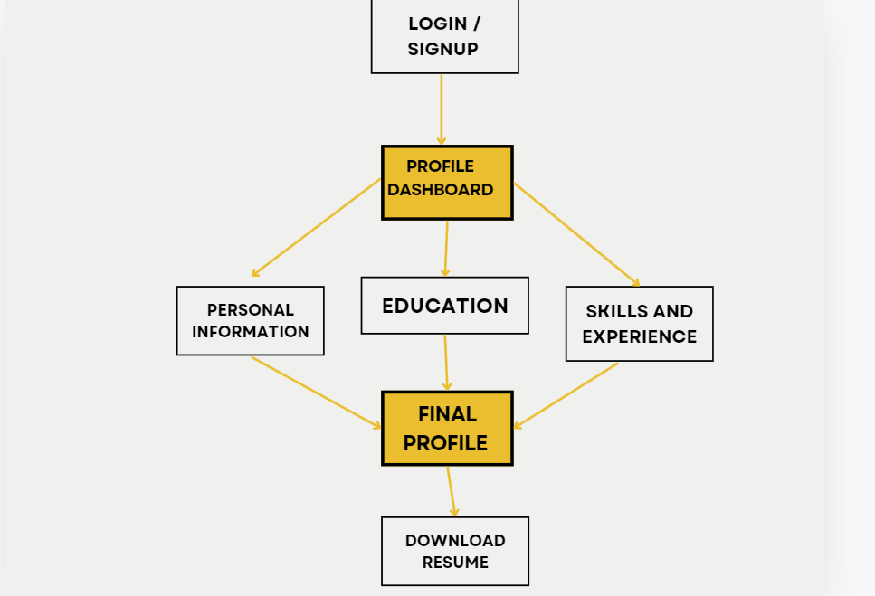

Figure 5.1: Block Diagram of Resume craft

This figure shows the flow and features of the application using a simple diagram. The diagram contains the layout of the project where on login in user can see the homepage and it's various features like adding skills, qualification and experience etc. .

## Chapter 6

### Project Scheduling

### The project schedule utilizes a Gantt chart to visually represent the timeline and progress of key tasks. It outlines the start and end dates for each phase of the resume builder development, ensuring efficient time management and resource allocation throughout the project lifecycle.

**Gantt Chart**: A Gantt chart is a widely-used project management tool that provides a graphical representation of a project’s timeline. It helps illustrate the sequence of tasks, their durations, and the relationship between different tasks. Each task is represented as a horizontal bar, with the length corresponding to the time it takes to complete that task.

1st week of August: Creating a Basic GUI of a login page and Signup page and connecting it to MySQL

2nd week of August: Creating dashboard for skills experience and qualification that connects it to MySQL

3rd week of August: Creating a label to add user profile photo that can also be edited later and Connecting this to MySQL

1st ,2nd week of October: Creating the final resume retrieving all information from profile page based on user input and connecting it the database.

By the end of October: Creating resume in downloadable format in pdf form saving in downloads folder .

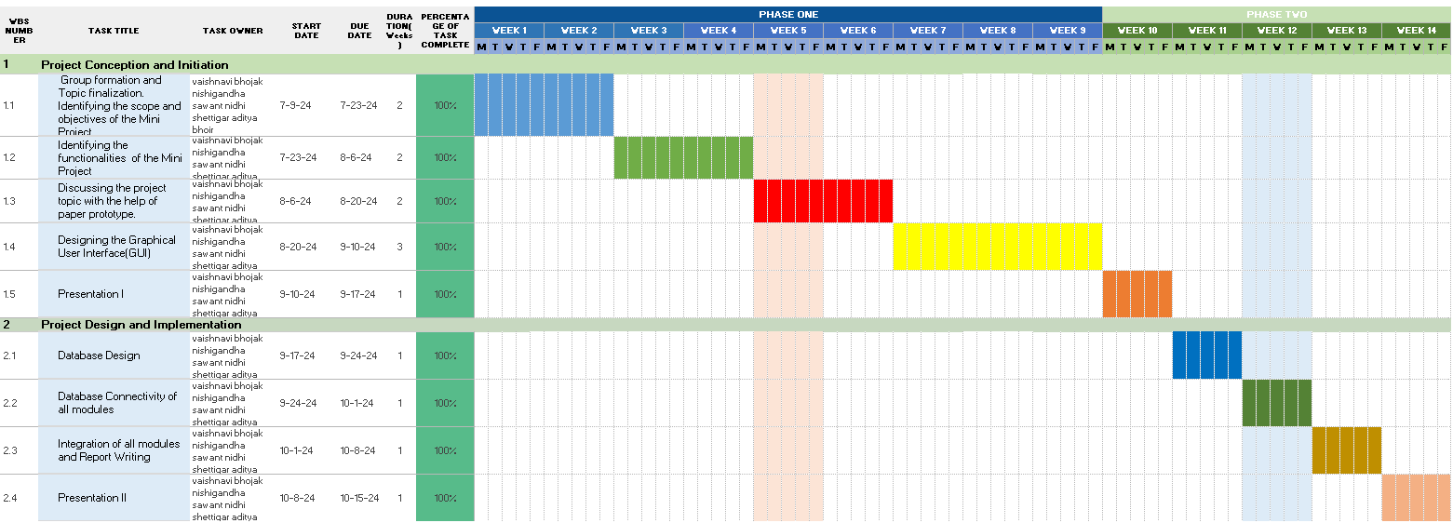

Figure 6.1 Gantt Chart

.6.1- This Gantt chart outlines our project timeline, split into two phases: Project Conception and Initiation and Project Design and Implementation. It shows task durations, start and end dates, and completion status. Phase one tasks like group formation and GUI design are complete. Phase two focuses on database design and report writing, with tasks scheduled for later weeks.

## Chapter 7 Results

### Functionality achieved:

* + - * The resume builder successfully allows users to add their skills, qualifications, and experience. Each resume can be customized with relevant details and easily downloaded, providing users with an organized way to present their professional information.

### Profile Picture and PDF Download:

* + - * The resume builder allows users to upload a profile picture for a personalized resume. Additionally, users can download their resume as a PDF, providing a professional and easily shareable format for job applications.

### User Interface:

* + - * The app features a clean and simple interface. It uses intuitive buttons and dashboard for adding, editing, and deleting resume.

### Database Management:

* + - * The data (skills, qualifications, experience, and profile information) is stored in a MySQL database, ensuring that user data is securely saved and can be accessed or modified at any time.

#### Sign up page:

#### 

Figure 7.1 Sign-up page

* 1. : This page allows new users to register to Resume craft

#### 2. Login page:

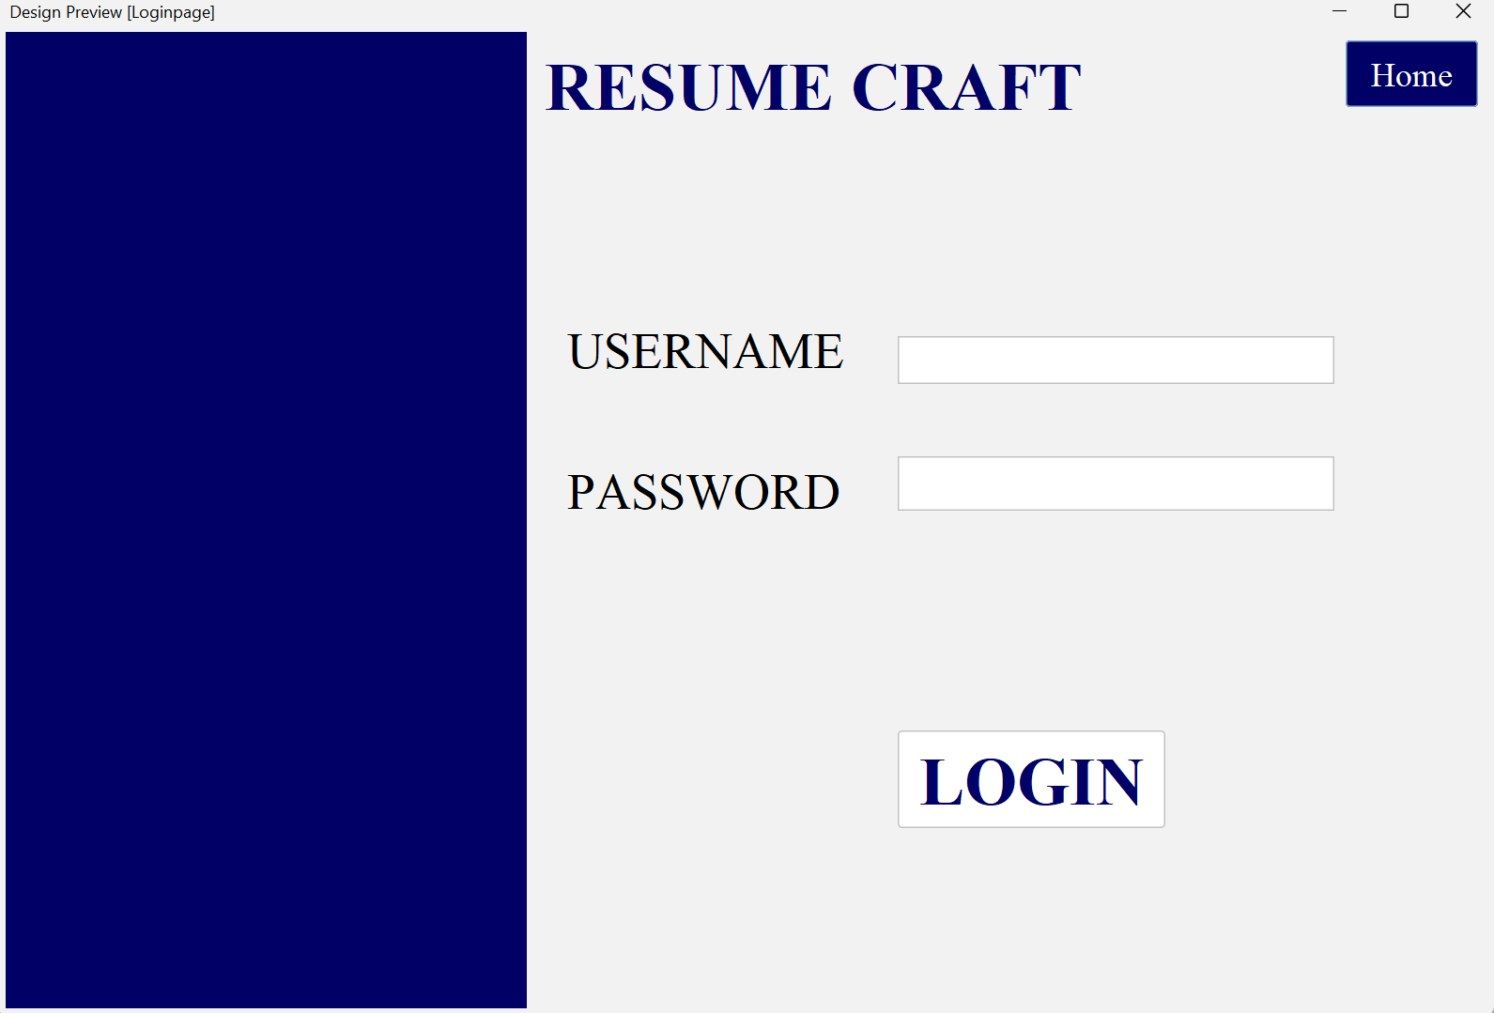

Figure 7.2: Login page

7.2 Allows users to login into Resume craft

#### 3. Homepage:

#### 

Figure 7.3: dashboard page

7.3: Depicts various features in dashboard like personal information, qualification, and skills and experience

4. profile page

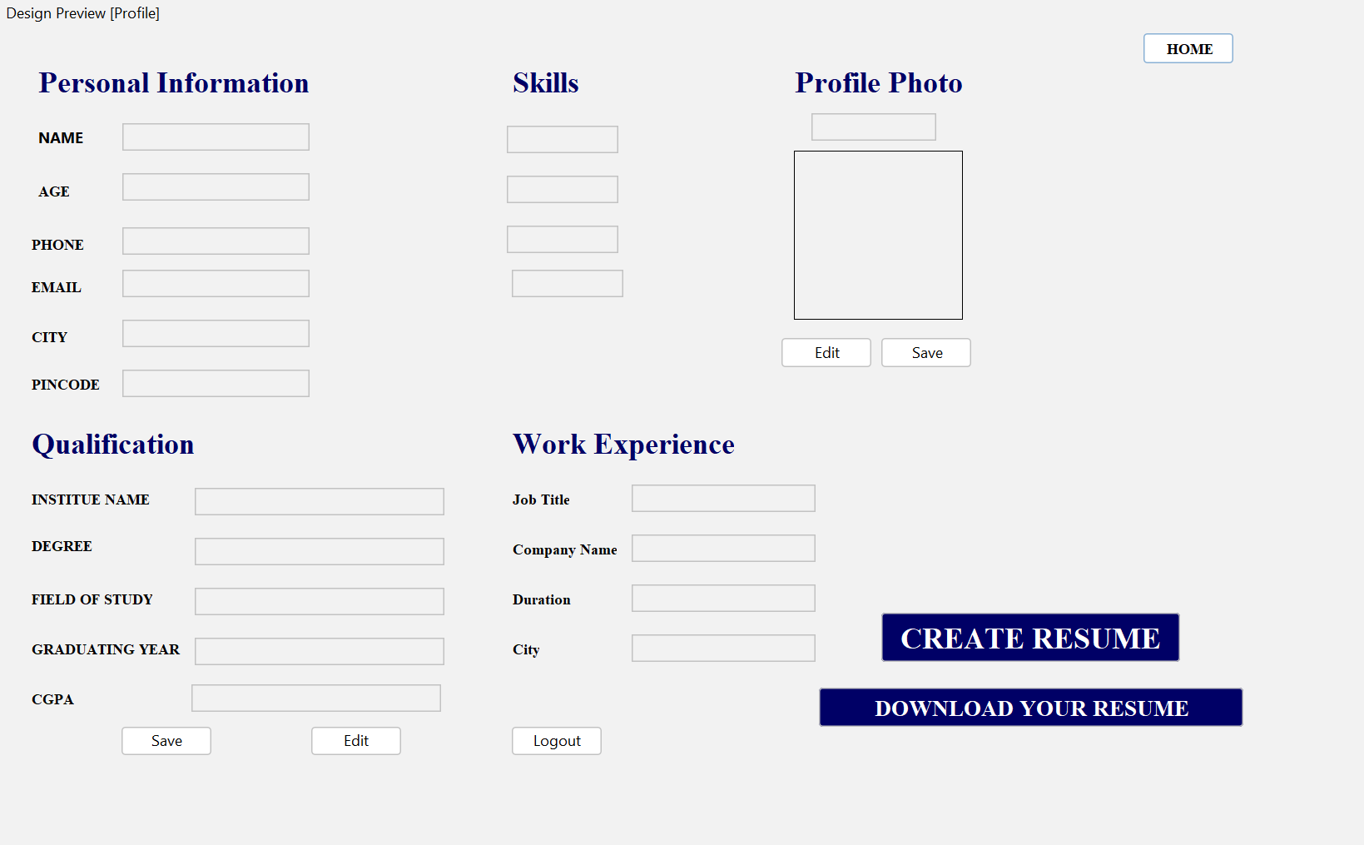

Figure 7.4 profile page

7.4 : allow user to edit information and their photo

#### 5. Final page -

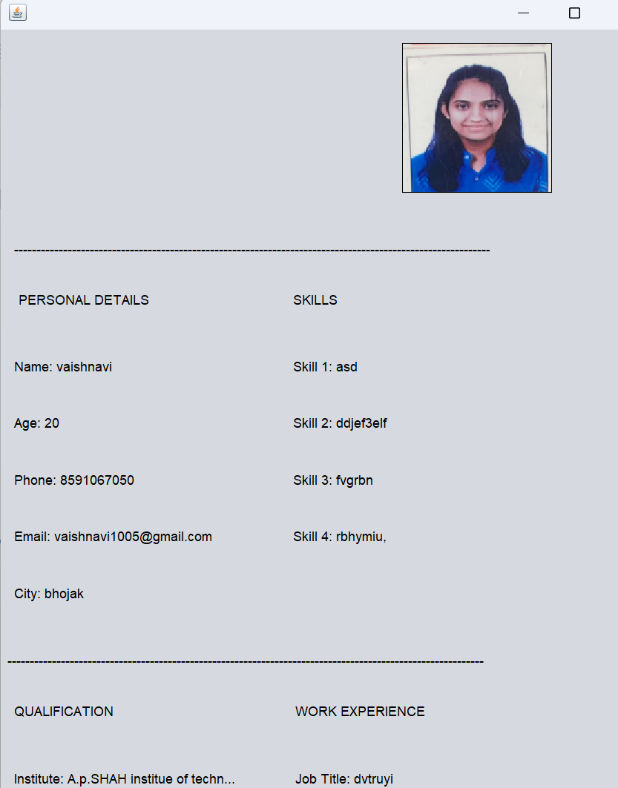

Figure 7.5: resume page

This page shows final resume page a display before downloading in pdf format.

6. Pdf format

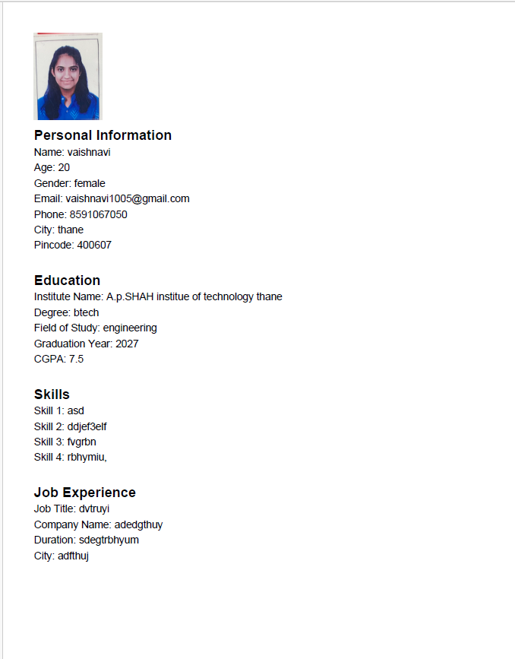

Figure 7.6: resume pdf

7.6- this page is the final pdf formatted resume

**Chapter 8**

Conclusion

In conclusion, the resume builder stands out as a comprehensive and highly efficient tool designed to streamline the traditionally time-consuming process of creating professional resumes. This platform is built with a strong focus on user experience, offering a simple, intuitive interface that allows individuals to easily input, update, and organize their personal and professional information. Users can seamlessly enter key details such as education, work experience, skills, and qualifications, all of which are neatly formatted into a cohesive resume that is both professional and visually appealing. The inclusion of features such as profile photo uploads and the ability to download resumes in PDF format further enhances the user experience, offering flexibility and customization to suit diverse professional needs.

One of the platform’s key strengths is its use of modern technologies like Java for the front-end interface and MySQL for secure data storage. JavaFX ensures that the user interface is responsive and easy to navigate, making it accessible even to users with limited technical knowledge. Meanwhile, MySQL plays a critical role in maintaining the integrity and security of user data, ensuring that all personal information, including skills, qualifications, and profile photos, is stored securely and can be easily accessed or modified at any time. The use of these technologies not only provides a stable and reliable system but also ensures scalability, allowing the resume builder to evolve with future feature enhancements or increased user demands.

Additionally, the resume builder contributes to improved productivity for job seekers by reducing the time and effort typically spent formatting and organizing resumes. With customizable templates and guided prompts, users are able to focus more on the content of their resumes rather than the technical aspects of layout and design. This leads to a more efficient process, where users can quickly create resumes that are polished and well-structured, suitable for immediate submission to potential employers. The ability to download resumes as PDFs ensures compatibility with most application processes, allowing users to share their resumes in a widely accepted format that maintains its formatting across platforms.

The platform's focus on professionalism and personalization helps job seekers present themselves in the best possible light, giving them a competitive edge in the job market. By offering features that cater to specific job needs and allowing resumes to be tailored to different industries, the resume builder helps users craft resumes that are not only comprehensive but also targeted. This ensures that users are able to present their qualifications, skills, and experiences in a way that resonates with hiring managers and recruiters, increasing their chances of securing job interviews.

Moreover, the modular and scalable design of the resume builder sets the foundation for future enhancements. As user needs evolve, new features can be added to the platform, such as advanced resume templates, integration with job boards, or automated keyword suggestions to optimize resumes for applicant tracking systems (ATS). The platform's flexibility and adaptability make it a future-proof solution in the ever-changing job market landscape.

Overall, the resume builder is not just a tool for creating resumes—it is an essential resource that empowers users to present their professional qualifications in a streamlined, effective, and polished manner. It simplifies the resume-building process, making it accessible to users of all experience levels while ensuring that the end result meets modern standards for professionalism. Whether for a recent graduate entering the workforce or an experienced professional looking to advance their career, the resume builder is a valuable asset in helping users stand out in a competitive job market. As the platform continues to grow and adapt to new technologies and user feedback, it is poised to become an even more indispensable tool for job seekers worldwide.

### References

1. Patel, R., & Singh, P., “A Comparative Study of Resume-Building Tools: Features, Usability, and Efficiency,” *Journal of Career Development Technologies*, March 2018, pp. 230-23 230-23.
2. Thompson, L., & Martinez, D., “Innovations in Digital Resume Creation: A User-Centric Approach,” *International Journal of Digital Platforms*, July 2021, pp. 45-51.
3. Wilson, K., & Zhao, M., “Enhancing Job Search Success with Automated Resume Builders,” *ResearchGate*, October 2019, pp. 320-328.
4. O’Connell, J., & Fisher, A., “The Evolution of Resume Formats in Digital Job Markets,” *Journal of Employment Technology*, June 2022, pp. 150-156.
5. Gupta, A., & Brown, S., “Optimizing Resume Layouts for Applicant Tracking Systems,” *Tech Innovations in Career Services*, December 2020, pp. 88-94.